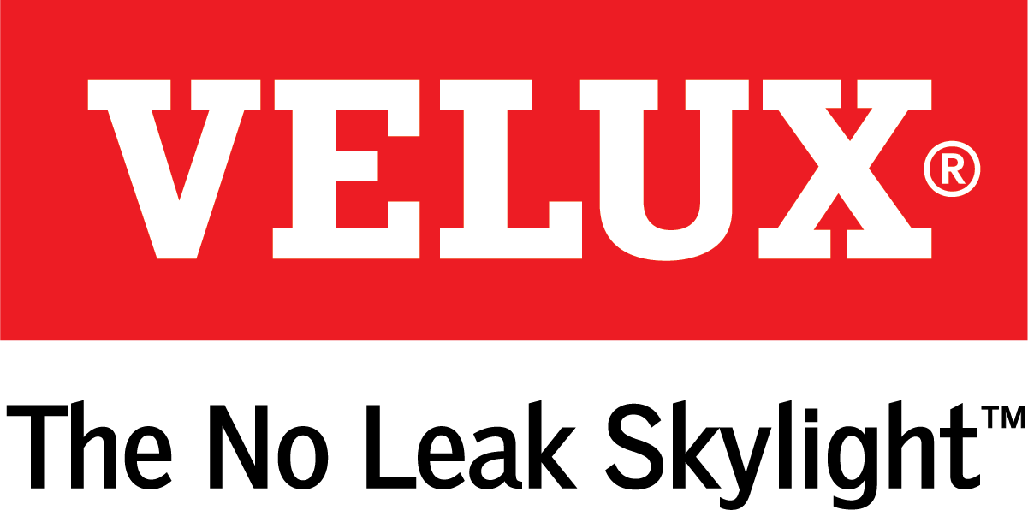
Media Contacts:
Ashley Moran
704-926-1376
amoran@wrayward.com

Dana Haydock
704-926-1301
dhaydock@wrayward.com

VELUX® AMERICA OFFERS PREVIEW OF SKYLIGHT AUTOMATION SYSTEM

VELUX Active makes smart home technology even smarter

ORLANDO, Jan. 9-11, 2018 – VELUX, the world leader in skylights and roof windows, recently introduced VELUX Active technology. International Builders’ Show attendees can preview the system at the VELUX booth W3117, and the system is expected to be available to the public in fall 2018.
The system allows homeowners to pair home automation with skylights to more easily infuse natural light and fresh air into the home. The product introduction will support the growing desire for smart home technology in the United States. In fact, some projections show the number of connected homes will exceed 35 million by 2021.
VELUX Active, developed in conjunction with Netatmo technology, gives homeowners additional control over their new or existing VELUX Skylights. The system ensures a healthier indoor climate by automatically ventilating two-to-three times daily to remove stale, harmful air.
“VELUX Active makes it even easier to achieve a healthy indoor climate,” said Ross Vandermark, national product manager for VELUX America. “Without having to program or operate a remote, the system has the ability to recognize a need for fresh air and open the skylights automatically.”
Smart sensor technology monitors CO2, humidity levels and temperature in the home, and the system will automatically open the skylights if fresh air is needed. In an average home, the pollutant level is normally at a low level when people first enter the home, or after effective ventilation. However, after an extended period of time, daily activities can raise the level of pollutants to unhealthy levels that can cause headaches, dizziness and sleepiness. Proper ventilation removes unwanted toxins from the home and promotes an overall healthier lifestyle for the inhabitants.
“In addition to the benefits of automatically opening and closing skylights and skylight blinds, the system offers homeowners data on the health of their homes,” added Vandermark.
VELUX Active is operated by a smartphone app and integrates with Apple HomeKit. In addition to visualizing the health of their home, users will be able to operate the skylights using their smartphone – even if they are away from the house. The system also uses local weather forecasts along with smart sensor technologies to open and close skylights and skylight blinds. VELUX Active has the capability of integrating with smart speaker technology so that users can control skylights using voice activation.
The system is expected to be available to the public in fall 2018. For more information, visit velux.com/active.

# # #

VELUX is the world leader in skylights and roof windows and is one of the strongest brands in the global building materials sector. VELUX America products are available nationwide through home centers, building material suppliers, lumberyards and independent door, window or roofing retailers. Consumers can locate local suppliers and installers and access information on skylight selection and the benefits of bringing more natural light and fresh air into the home by visiting www.veluxusa.com or www.whyskylights.com. VELUX skylights are made in America in Greenwood, South Carolina.

