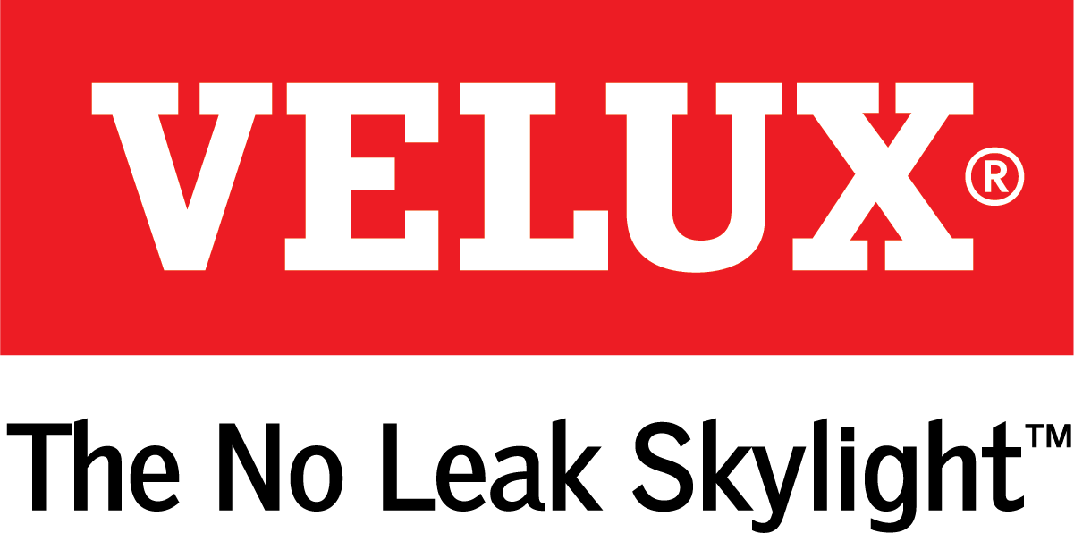
Media Contacts:
Ashley Moran
704-926-1376
amoran@wrayward.com

Dana Haydock
704-926-1301
dhaydock@wrayward.com

VELUX® Skylight Blinds Add Style and Function to the Fifth Wall

Skylight Blinds Bring Effortless Design to Any Space in a Home

ORLANDO, Jan. 9-11, 2018 – For many homeowners, customizing their space to fit personal style is paramount. VELUX, the world leader in skylights and roof windows, provides the skylight accessories to do just that. Not only will skylights bring in fresh air and natural light, but adding designer blinds allows homeowners to add a touch of color or pattern to the fifth wall while helping control the amount of light that shines through with skylight blinds.
“Colorful skylight blinds draw the eyes up to the fifth wall and create a new sense of space,” said Ross Vandermark, national product manager for VELUX America. “Typically, we think of art and wall color as vehicles to personalize a space and limit this to just four walls. With the wide variety of colors and patterns, skylight blinds are a design element shouldn’t be overlooked. They can tie a color scheme together or create a new focal point on the ceiling.”
The addition of skylight blinds, available in light blocking or light filtering models in more than 75 colors, adds a new dimension to a VELUX skylight experience. Tasha, the home décor expert behind the blog Designer Trapped in a Lawyer’s Body, added three VELUX No Leak Solar Powered “Fresh Air” Skylights to her master suite. Skylight blinds in Navy Blue not only give her light control, but also provide a pop of color.
At any given time of the day, light levels can be customized with skylight blinds to create the perfect atmosphere for any activity. From coloring with the kids to taking a light nap on the couch, skylight blinds provide the perfect amount of light.
“Skylight blinds are an incredible tool to creating an energy-efficient home,” said Vandermark. “When closed, the double pleated, room darkening blind boosts the overall energy performance of the Energy Star®-certified skylight by 40 percent.”
Solar powered skylight blinds are eligible for a 30 percent federal tax credit. They are the perfect way to control light and a natural design element to add to any new or existing VELUX skylight.

To learn more about VELUX skylight blinds, visit us at IBS booth W3117 or at the VELUX Blind Shop.

# # #

VELUX is the world leader in skylights and roof windows and is one of the strongest brands in the global building materials sector. VELUX America products are available nationwide through home centers, building material suppliers, lumberyards, and independent door, window, or roofing retailers. Consumers can locate local suppliers and installers and access information on skylight selection and the benefits of bringing more natural light and fresh air into the home by visiting www.veluxusa.com or www.whyskylights.com. VELUX skylights are made in America in Greenwood, South Carolina.

